

TryDeFi –Using Uniswapor AaveTestnets

School:.............................................................................................................Campus:....................................................... AcademicYear:......................SubjectName:...........................................................SubjectCode:..........................

Semester:...............Program:........................................Branch:.........................Specialization:.......................... Date: .....................................

(LearningbyDoingandDiscovery)

**\* Coding Phase: Pseudo Code / Flow Chart / Algorithm**

ALGORITHM:

Step 1: Open MetaMask wallet and connect to an Ethereum test network (Sepolia / Goerli).  
Step 2: Obtain faucet ETH and required test tokens (e.g., DAI, USDC).  
Step 3: Access the Uniswap testnet interface.

* Select the trading pair (e.g., ETH → DAI).
* Enter the swap amount.
* Confirm and approve the transaction in MetaMask.
* Verify the updated token balance.

Step 4: Access the Aave testnet interface.

* Deposit test DAI into the Aave pool.
* Approve the transaction in MetaMask.
* Borrow ETH using DAI as collateral.
* Verify borrowed assets in MetaMask and updated balances in Aave dashboard.

Step 5: Check all transactions on the testnet block explorer (Etherscan testnet).  
Step 7: Record the results and observations.  
Step 8: End the experiment.

# * Softwares used

* MetaMask Wallet (for account and assets)
* Goerli/Sepolia Testnet (for ETH & test tokens)
* Uniswap Testnet Interface (for token swaps)
* Aave Testnet Interface (for lending/borrowing)
* Block Explorer (Etherscan testnet)

First check the metamask wallet for sepolia testnet if there is no sepolia testnet available then faucet it from sepolia faucet google cloud

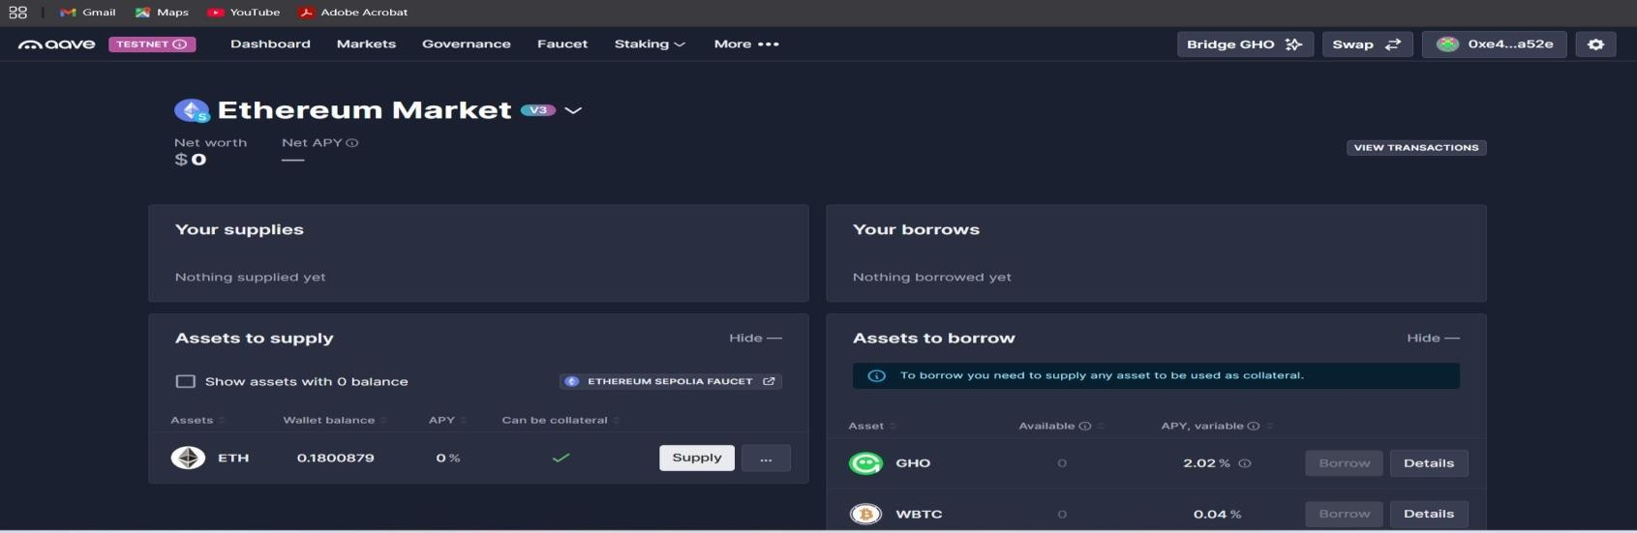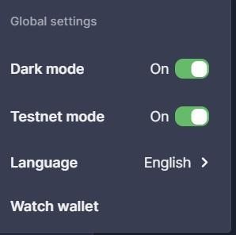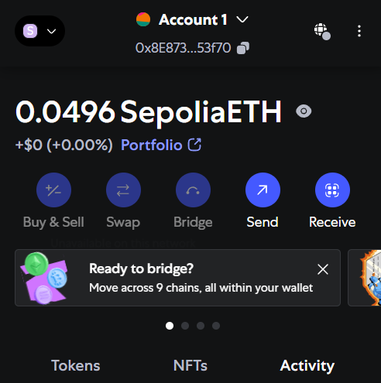

Then go to the website [www.aave.com](http://www.aave.com/) for swap the ethereum to DAI testnet token

Then in right top corner enable testnet mode

Then click on swap ,choose ethereum network and to DAI testnet token

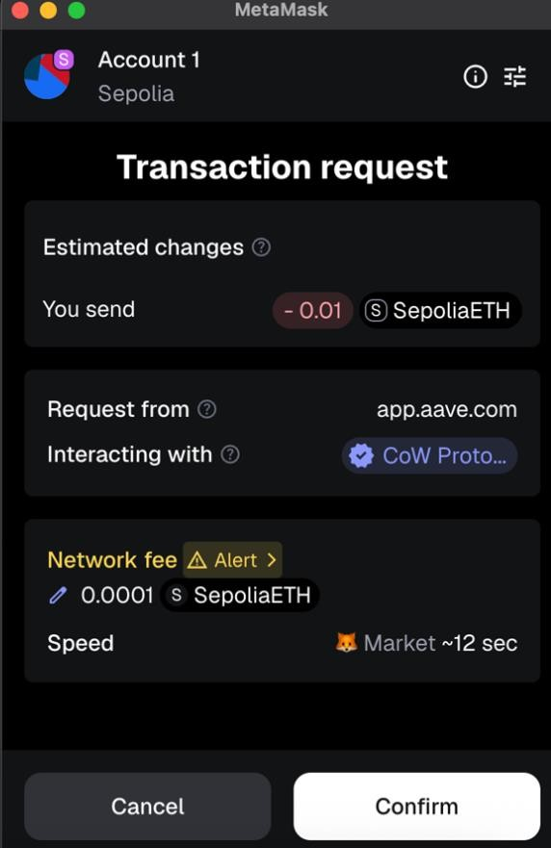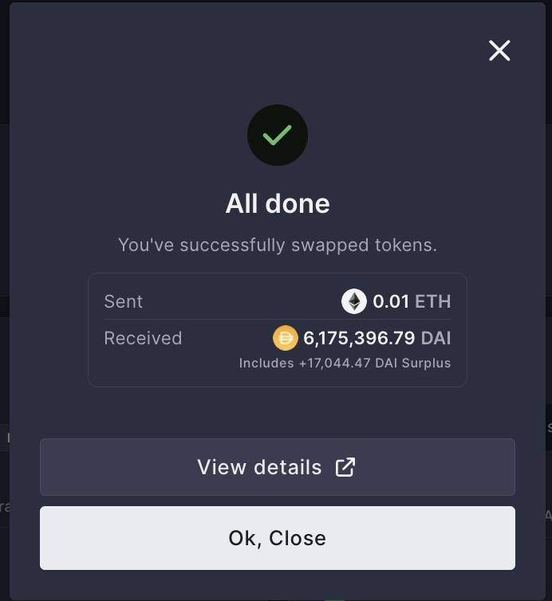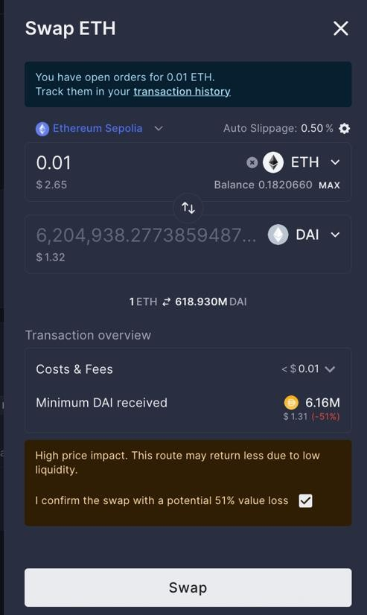

Then confirm the transaction in metamask wallet then you see the

order was confirmed

**\* Implementation Phase: Final Output (no error)** Applied and Action Learning

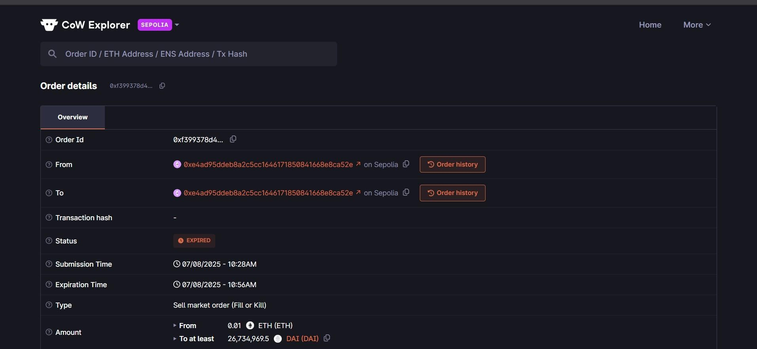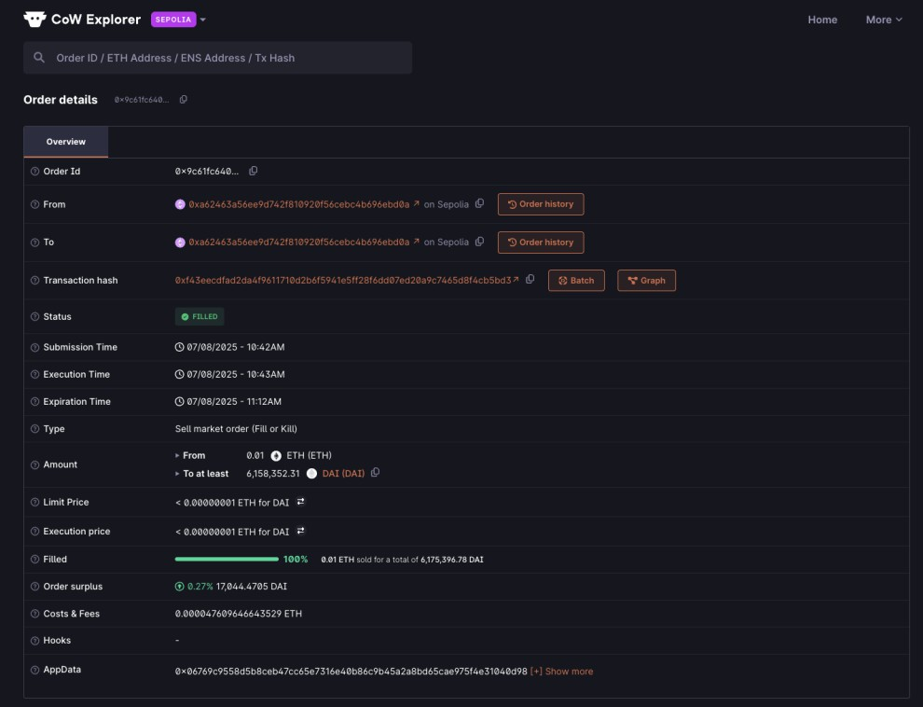

Nowaftertheorderconfirmedthenclickonviewdetailstoseeallthedetailsaboutthetransactionslike wallet address of from and to and hash ,timestamp etc.

# * Observations

* MetaMask successfully connected to testnets and funded with faucet ETH.
* Uniswap swap transactions executed and confirmed on block explorer.
* Aave deposit and borrow actions were processed smoothly with updated balances.
* Transaction hashes verified network activity, confirming the smart contracts executed correctly.



|  |  |  |  |
| --- | --- | --- | --- |
| **Rubrics** |  |  |  |
| Concept | 10 |  |  |
| Planning and Execution/  Practical Simulation/ Programming | 10 |  |  |
| Result and Interpretation | 10 |  |  |
| Record of Applied and Action Learning | 10 |  |  |
| Viva | 10 |  |  |
| **Total** | **50** |  |  |

***Signature of the Student:***



***Signature of the Faculty:***